**Final Project Report**

**NSU Car Rental Service**

**Project Abstract:**

This is basically a rental system where user can book different types of vehicles. The whole project is made by using java swing. Several classes have been used to make the project handier, like JFrame, Jbutton, JLevel. In this report, we designed and developed a simple Car Rental Service. The purpose of this project is to make a project with smell demonstration of OOP with graphical user interface(GUI) programming in Java. The whole project is made in eclipse.

**Classes used in the project:**

Total classes is being used for this project. Also in this project there are every topics included that we learned in our regular class such as inheritance, interface, polymorphism, file etc. The used classes are Car, Customer, Rental, RentalView, Transaction, WarningCar, WarningCustomer, WarningReserve.

Developing is Swing and AWT. In a graphical system, a windowing toolkit is usually responsible for providing a framework to make it relatively painless for a graphical user interface (GUI) to render the right bits to the screen at the right time. Both the AWT (abstract windowing toolkit) and Swing provide such a framework.

#### **Description on Project Working:**

At the beginning frame user will get to see the company name which is “NSU car rental” along with a table which will ask user to put todays date. This portion is made in Rentalview class.



After entering date, there is a button which will take user to the next page. The next page is for reserving date for the vehicle and also to take user’s date of birth. We have given this option to calculate user’s age. This portion is also done in RentalView class.

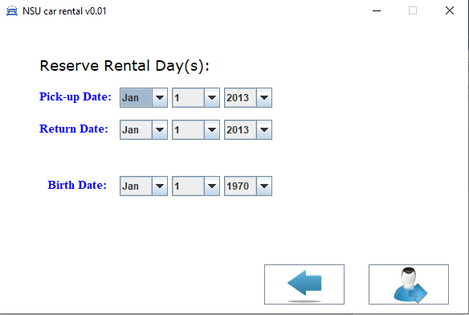

The next page is for customer data. The application will take all necessary data from user is this page such as name, gender, location etc. this part is also developed in RentalView.java

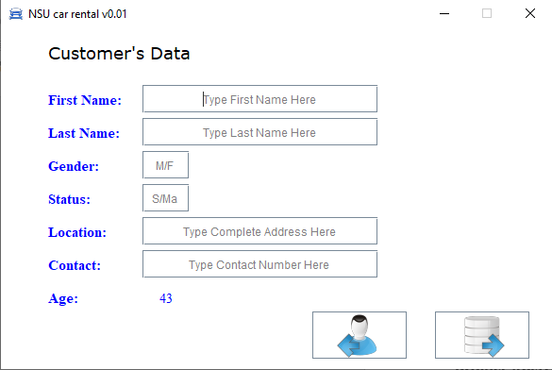

After filling all details the next page will bring our offered cars for user. For each car user will find its short description and also its price. User can choose any one vehicle from this part.

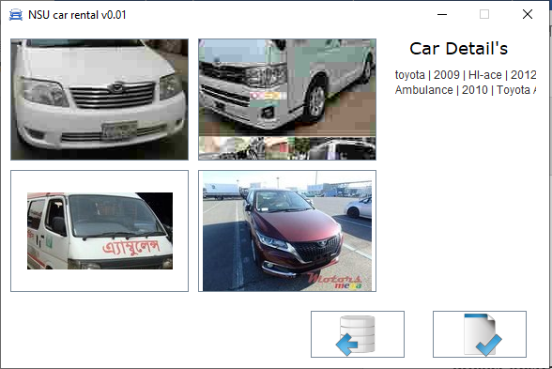

Therefor after filling each page with proper command, the application finally brings you the transaction page which is created in Transaction class. This will calculate your total bill according to you enter the total days and the car you want to rent.